**Safkat Salam Nabil** 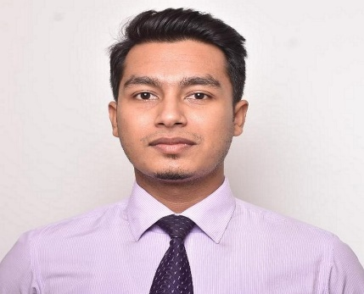

4th floor, South Garden, House-4, Road-02, Block-D, Mirpur-1216

Contact Number: +8801829563372

E-mail: [n_safkat@yahoo.com](mailto:n_safkat@yahoo.com)

**Career Objective:**

Willing to work in a challenging and competitive environment where a strong sense of responsibility and commitment requires. Where dignity of work provides job satisfaction and the place provides potential avenues for learning and growing and for achieving top level in the hierarchy of the company.

**Employment History:**

1. **Operations Officer: (July-2017 to till now)**

Galaxy Facilitation Services Limited

Delta Life Tower (4th Floor) Plot # 37 Road # Dhaka 1212, 90 Madani Ave, Dhaka

Department: Operations

**Duties/Responsibilities:**

1. Customer services i.e. application submission, value-added service selling, complain feedback (over phone and email both)
2. Document and data management
3. Handle customer queries, cash & bank related transactions
4. Sales reporting monthly and yearly (through power point presentation)
5. Daily reporting i.e. financial transaction, sales, system update and application error
6. Data entry
7. Ensuring all administration and logistics of passport delivery to consulate/ customer/ logistic etc.
8. Inventory management
9. Error monitoring

**Skills:**

**Computer efficiency:**

Operating System: MS-Office (word, excel, power point), Windows

**Language efficiency:**

English Both written and oral communication

Bangla Both written and oral communication (Chattogram local language as well)

Hindi Oral communication

|  |  |
| --- | --- |
| **Education:** |  |
| **Masters of Business Administration (MBA)**  East West University  Major in Marketing | **2019-2021** |
| **Bachelor of Business Administration (BBA)** | **2013-2016** |
| IUBAT—International University of Business Agriculture and Technology  Major in Finance and Banking | |
| **Higher Secondary Certificate (HSC)** | **2010-2011** |
| Dhaka Commerce College  Group: Business Studies | |
| **Secondary School Certificate (SSC)** | **2009-2010** |
| Chakaria Korak Bidyapit  Group: Business Studies | |

**Extra-curricular activities:**

Traveling, Voluntary works, Playing (Cricket, Table-Tennis, Carrom)

**Training Summary:**

Internship

Investment Mechanism of IBBL: Special Focus on HPSM (Hire Purchase under Shirketul Melk)

Islami Bank Bangladesh Limited

13A/2A, Block B, Babar Road, Mohammadpur, Bangladesh

Duration: 60 days

Year: 2016

|  |
| --- |
| **Personal Details :** |
| |  |  |  | | --- | --- | --- | | Father’s Name | : | Rahmat Salam | | Mother’s Name | : | Hasina Aktar | | Date of Birth | : | March 26, 1995 | | Gender | : | Male | | Height | : | 173.784 cm | | Marital Status | : | Married | | Nationality | : | Bangladeshi | |  |  |  | | Passport No | : | BP0111846 | |  |  |  | | Religion | : | Islam | | Current Address | : | 4th floor, South Garden, House-4, Road-02, Block-D, Mirpur-1216. | | Permanent Address | : | Hazi Bari, Natun Mahal, Chawfaldandi, Cox’sbazar sadar, Cox’sbazar. | |

**References:**

1. Arif Ahsan

Assistant Professor

IUBAT-International University of Business Agriculture and Technology

Email: [arif.ahsan@iubat.edu](mailto:arif.ahsan@iubat.edu)

Cell: 880837411533

1. Md. Mahbubur Rahman

Senior Principal Officer

Islami Bank Bangladesh Limited

Email: [mahbub0266@islamibankbd.com](mailto:mahbub0266@islamibankbd.com)

Cell Phone: +8801715028103

Sincerely yours.



**Safkat Salam Nabil**